ISO 9001:2000 QUALITY MANUAL

WOLSTENHOLME INTERNATIONAL LIMITED

CONTENTS

1.0 Scope of the Quality Management System at Wolstenholme International Limited

1.1 Statement of Quality Policy

2.0 Quality Management System Documented Proceedures

2.1 Document Control

2.2 Control of Quality Records

2..3 Internal Quality Audits

2.4 Control of Nonconforming Product

2.5 Corrective Action

2.6 Preventative Action

3.0 Quality Management System Processes and Interrelations

3.1 Organisation Charts

3.2 Responsibilities

3.3 Interrelation of Processes

3.4 Processes

1.0 Scope of the Quality Managment System at Wolstenholme International Limited

Wolstenholme International Limited is a Company with a long-standing successful history of supplying metal powders, pastes, pellets, varnish, offset ink, flexographic ink and other related products for use in a large range of applications, on a worldwide basis. The scope of the Quality Management System encompassess all activiities on the Darwen Site.

The Metallic Powders Operation at Darwen is responsible for the manufacture and supply of metal powders and pigments mainly in aluminium, copper and brass (bronze) based alloys, for use in printing, inks, plastics and other industrial and engineering applications.

The Ink Operation at Darwen is responsible for the manufacture of a wide range and type of printing ink, 'one-pack' gold ink, varnish and related printing products.

All production processes at Darwen are validated before leaving the site and as such sub-clause 7.5.2 is excluded.

The overall operation at Darwen is controlled by the Ink & Print business unit and the Industrial business unit.

Technical Service and Research and Development are vital to the future development of the Company, together with understanding and developing new products and applications for our customers.

The manufacturing, technical and administration functions of the Company are based in Darwen, Lancashire, England and employ some 210 staff at that location.

Through the application of Quality Management Systems and Company wide training programmes, Wolstenholme International Ltd. is committed to ensuring continuous improvements to both its processes and product technology.

WOLSTENHOLME INTERNATIONAL LTD.

QUALITY POLICY

Wolstenholme International Limited is committed to the provision of customer satisfaction. Quality in everything we do is the central ingredient in the above commitment. Our commitment goes beyond maintaining a quality system which fully complies with the requirements of BS-EN-ISO 9001. We are committed to achieving, maintaining and improving overall organisational performance and capabilities by the application of the principles outlined in BS-EN-ISO 9004:2000

We will maintain and continuously improve our quality management system by the setting of measurable quality objectives throughout the organisation and vigorous internal audits. We will review our performance at regular management reviews. Additional inputs to these reviews will also include customer feedback, process performance and product conformance. The prime output of the review will be to ensure continuing customer satisfaction and improvement of products.

As part of this commitment we will identify and meet the training needs of our employees, so ensuring that the needs of our customers are met. This Policy will be made available throughout our organisation to ensure that the commitment to our customers is clear and widely understood.

Chris Ravenscroft
Managing Director

2.0 Quality Management System Documented Procedures

2.1. Document Control

All quality system documentation will be made available via supervision in the Triangle ISO Achiever Plus databases. All documents relating to the quality system will be controlled. Changes to quality system documentation may be proposed by any member of the Company. Such proposed changes will be reviewed by the Management Representative who will liaise with other quality system documentation users as necessary. Dead Triangle ISO Achiever Plus documents will be archived within the databases.

REF: Control of Quality/ Environmental Documents- WIQSP.1

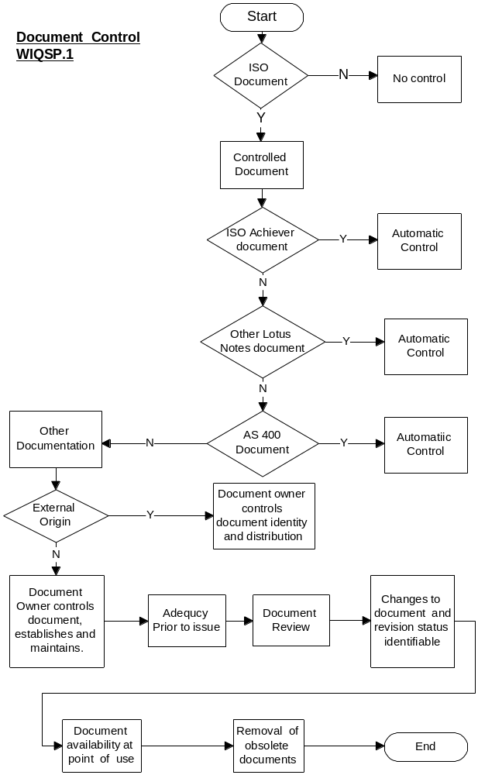

Control of Quality Records

All quality records will be maintained and controlled. The records will be legible and stored in such a manner as to protect them from damage, loss and deterioration. Quality records will also be stored and clearly located in such a manner as to facilitate easy retrieval of information.

REF: Control of Quality/ Environmental Records - WIQSP.2
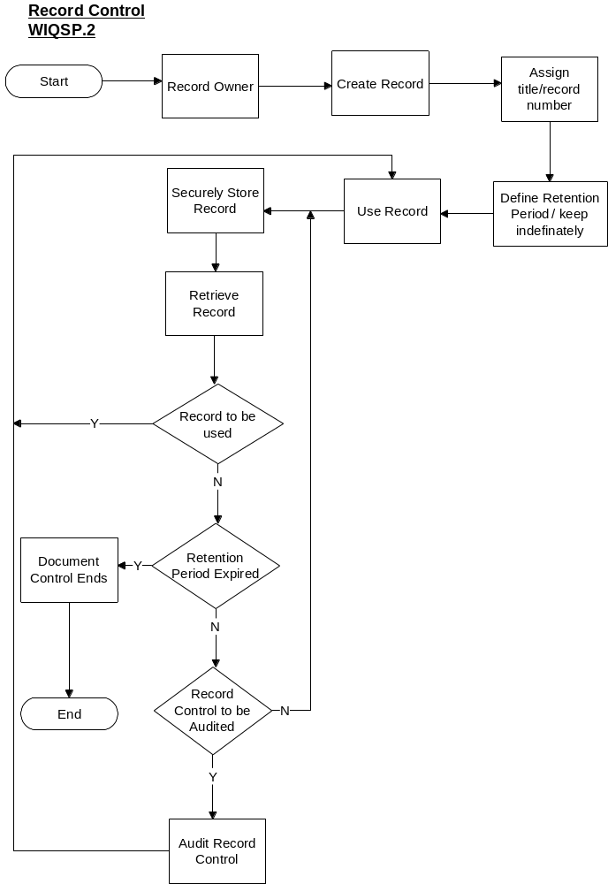
2.3 Internal Quality Audits

Internal audits will be carried out in accordance with Company procedures and will be conducted for any of the following reasons:-
(i) On a scheduled basis.

(ii) As a result of a customer complaint (part or full audit)

(iii) As a result of the need for new procedures to accommodate new business situations.

(iv) Un-scheduled Audits as requested by the Operations Director or Management Representative.

(v) Follow-up audits (part or full audits) will take place in order to establish the effectiveness of relevant audit related Corrective Action Requests previously raised.The management of internal audits will be the responsibility of the Management Representative, who will also be responsible for ensuring that any necessary corrective actions are satisfactorily implemented and closed out in the relevant department by the declared deadline date.

Internal audits will be carried out as laid down in the internal audit schedule by trained personnel having no direct involvement with the department, section or function being internally audited. If for any reason an audit cannot be completed as scheduled, the Management Representative will re-schedule as required.

REF: Internal Audits - WIQSP.3

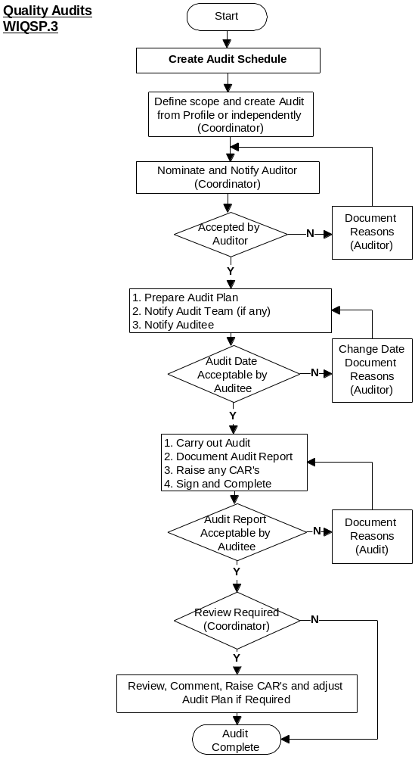

2.4 Control of Non-Conforming Products
All non-conforming products will be clearly identified with the relevant identification label, or held in clearly identified areas and removed from normal production or storage areas to await a disposal decision.
Where products are thought to be marginally suspect, and re-inspection or re-testing required, they will be clearly identified as such and only released for use subject to passing the re-testing stage and a suitable end use identified.
Where products are found to be outside specification, they may be re-worked in accordance with relevant procedures, or concession sought from the customer. Corrective and Peventitive actions will be implemented where necessary to determine the root cause of the non-conformance.
Non-conforming products detected at the goods inward stage will be rejected, and the question of disposal discussed with the supplier. The supplier will be advised of the rejection by the Purchasing Department.

REF:Control of Non-Conforming Products - WIQSP.4a, 4b and 4c

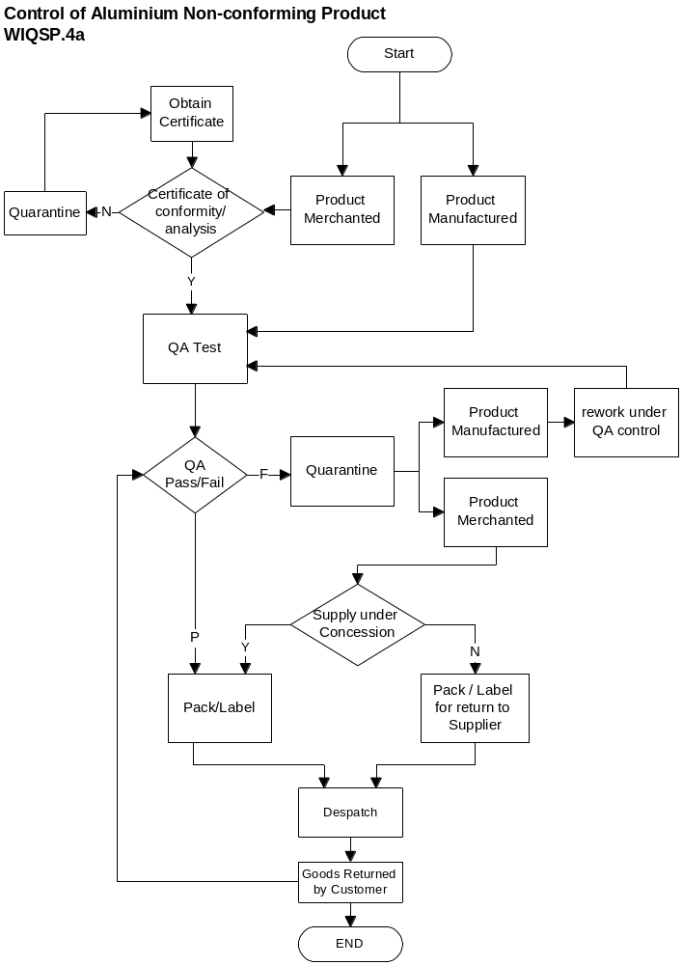
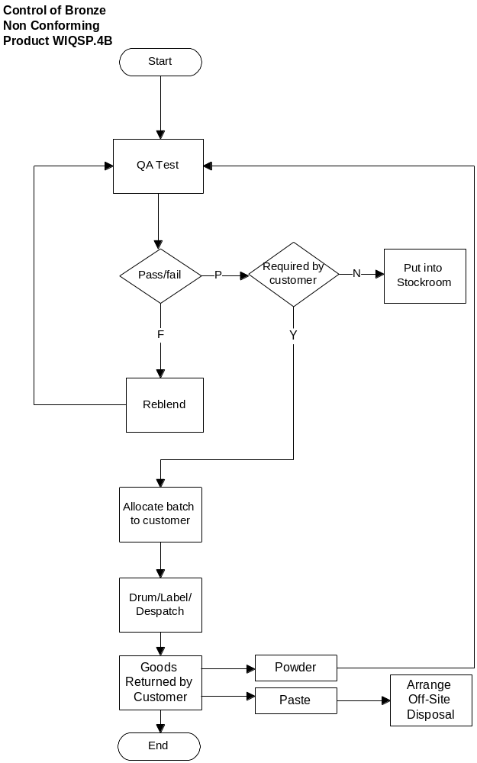
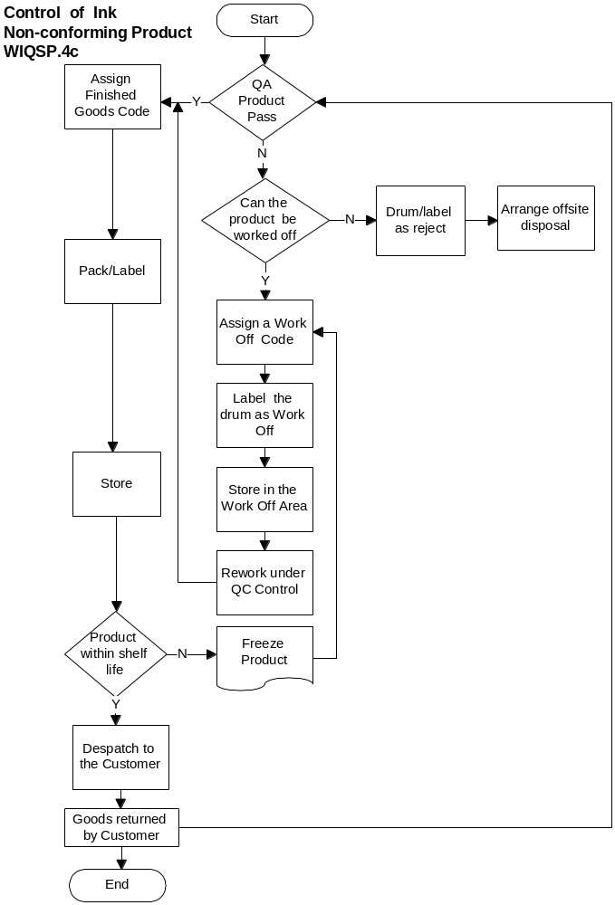

2.5 Corrective Action

Corrective action will be raised as a result of non-conformances identified during internal audits, when suppliers provide defective materials or services, when customers have cause to complain or following in-progress/ final inspection. Corrective action requests may also be raised in an effort to improve current working practises. Corrective actions and customer complaints will be reviewed at Management Review Meetings.
When non-conforming products or services are identified, the root cause of the problem will be investigated, corrective action taken and preventative measures initiated to preclude a recurrence.

REF: Corrective Action - WIQSP.5
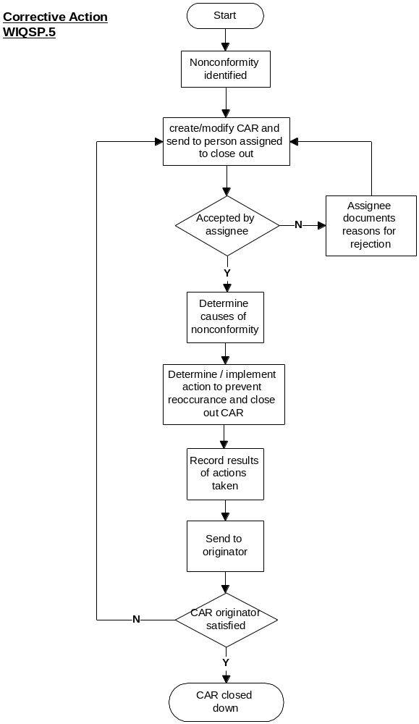

2.6 Preventative Action
Corrective action is taken as a result of Product or process nonconformity. It is hence a reactive measure and does not necessarily prevent further non conformance. Preventive action aims to identify product or process conformity before such an event happens and. is thus a proactive measure. The requirement for preventive action is established by the analysis and review of measurement data within the Company. All such data within the Company will be subject to evaluation as to the requirement for preventative actions to be taken in order that potential processes or product non conformities are identified.

REF: Preventative Action - WIQSP.6
3.0 Quality Management Systems Processes and Interrelations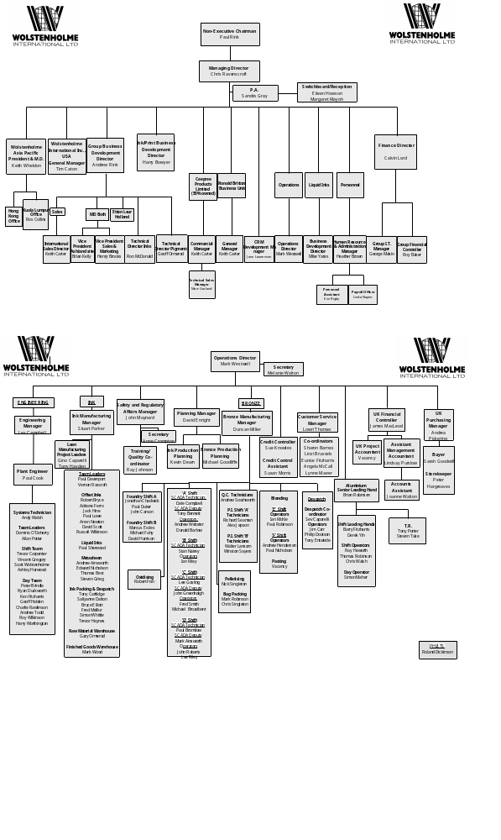
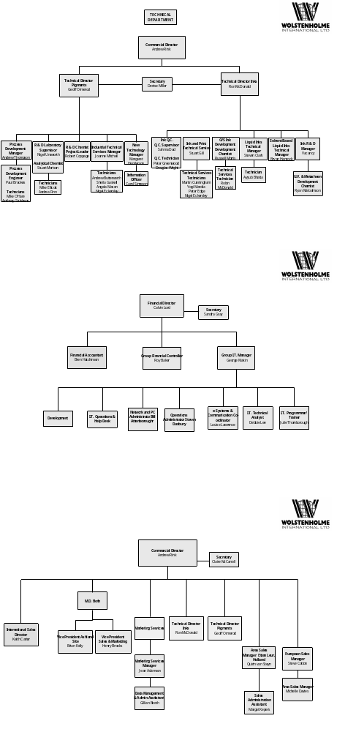

1.2.2 Responsibities

Managing Director

The Managing Director is responsible to the Wolstenholme International Ltd Board of Directors and has overall responsibility for all Company operations such as sales, quality, design and development of the products/ services supplied to the customer.

Operations Director

The Operations Director is responsible to the Managing Director for all production and engineering operations. The Operations Director also reports to the Board of Management on the operation of the ISO 9001 Quality System.

SARA (Management Representative)

The SARA Manager is responsible to the Operations Director for the upkeep and maintenance of the quality system to the requirements of BS-EN-ISO 9001 :2000 The SARA Manager (MR) represents the Company on all quality assurance matters, pertinent to the quality system as established by the contract requirements, regulatory requirements and quality policies and procedures.
The SARA Manager (MR) has the primary responsibility to structure the quality system which will involve all sections and also to ensure compliance with all quality system requirements.
Specifically, the Management Representative is involved in areas such as:-
- Drafting the policy on quality assurance of the Company along with the Operations Director.
- Setting the quality management objectives of the Company.
- Reporting on the performance of the Quality System at Management Review Meetings.
- Determining and reporting the principle causes of quality system non-conformances.
- Monitoring the quality system to determine where improvements are needed and monitoring the necessary corrective action.
- Maintain contact with the external Registration Body on matters relating to the operation of the Quality System.

SARA Manager is responsible to the Operations Director for the upkeep and maintenance of all the ISO Systems and the Company Health and Safety Policy. The SARA Manager is also responsible for driving the E,H&S policies within the Company.

Technical Directors

The Technical Directors for pigments and inks are responsible to the Managing Director .. and ink and print Director respectively for ensuring that processes and equipment are designed and developed such that product of the highest attainable quality is produced consistently and efficiently.

Human Resources and Administration Manager

The Human Resources and Administration Manager reports to the Managing Director and is responsible for managing all aspects of the personnel function, which includes the facilitating, co-ordinating, recording personnel issues and training, within Wolstenholme International Ltd.

Ink Manufacturing Manager

The Ink Manufacturing Manager is responsible to the Operations Director for the control of stocks, manpower and the process necessary to produce products to the correct specification within a given time.

Sales Directors

The Sales Directors are responsible to the Managing Director for ensuring that customers' requirements for the sale of printing/ industrial powders, pastes, pellets, inks, varnishes and related Company products are taken, reviewed and dealt with efficiently.

UK Financial Controller and Purchasing Manager.
The UK Financial Controller & Purchasing Manager is responsible to the Financial Director for the effective control and reporting of manufacturing costs incurred by the manufacturing facility at the Darwen site.
There is also a responsibility to the Financial Director for the effective and economic procurement of raw materials and consumables used in the business of the Company.

Research and Development Managers

Research and Development Managers are responsible to Technical Directors for managing Research and Development projects, maintaining customer contact during the project development stages and the general running of research laboratories.

Bronze Manufacturing Manager / Offset Ink R&D Manager

The Bronze Manufacturing Manager and Offset Ink R&D Manager (ink operations) are responsible to the Technical Directors for the agreement of specifications with the customer, and ensuring that there is a facility to continuously monitor and inspect the product to ensure that all such requirements are met.

Customer Services Manager

The Customer Services Manager is responsible to the Operations Director for the operation of Customer Services together with a team of administrators.

Production Supervision

Production is supervised in order to ensure that operations are carried out in line with process control work instructions and that customer requirements are met by way of our compliance with sales specifications.

3.3 Interelation of Processes
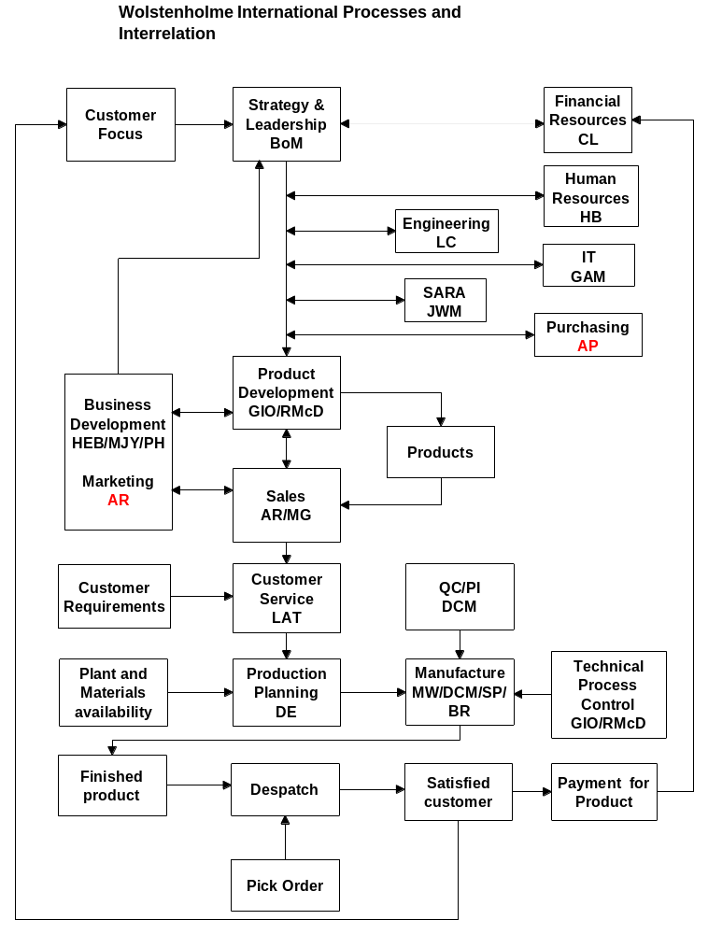
3.4 Processes
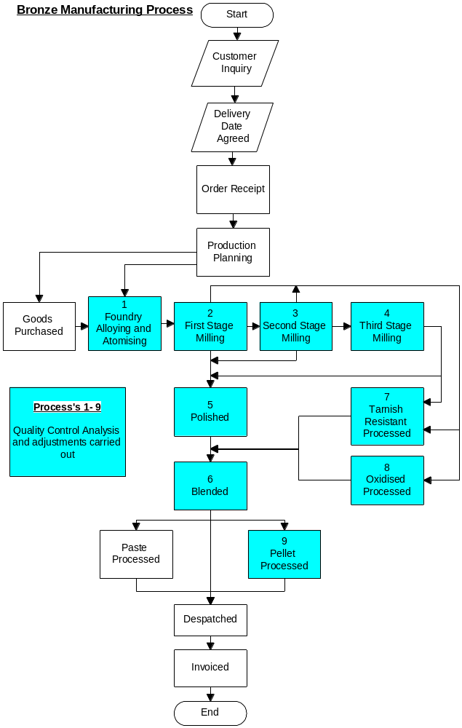
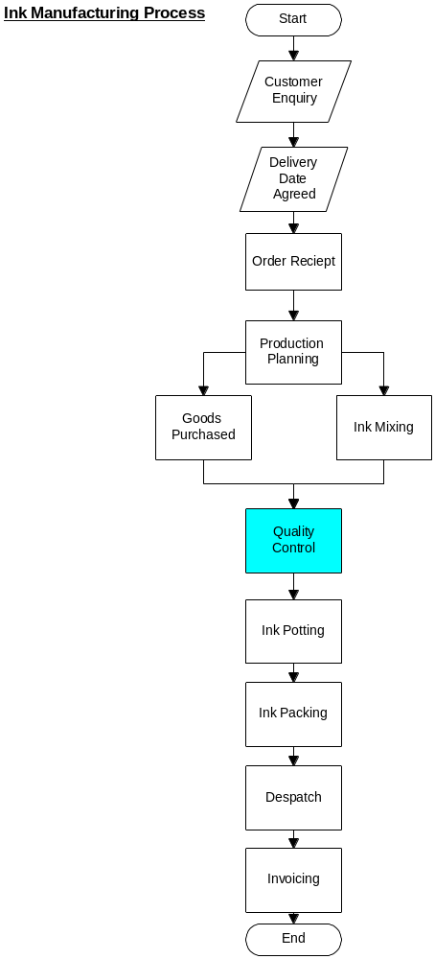
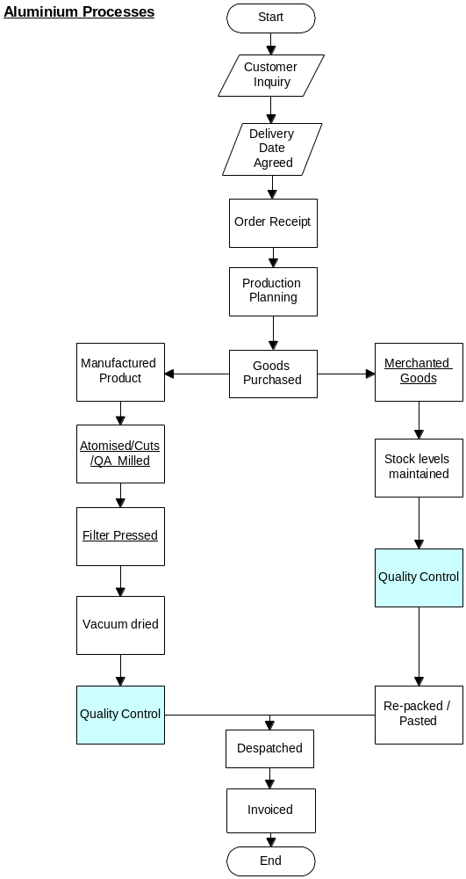
Start
New Recruit
Joins
Company
Stage 1
Induction
(Day 1)
Stage 2
Induction
(<1 Month)
Update
Review checks
Progress
Completed
Training
Evaluated
Level 1
Competencies
Assessed and
Checked
Next Level
Competencies
Identified
Main Development
Review.
Evaluates and
Identifies Any
Future Training
Needs
Competencies
Developed
and assessed
Training and Development
Records Kept
of all coloured
stages
Records
I.T. Training
Requested
Personnel informs
SARA Dept - Specific
H & S Training Carried
out as Appropriate
(<1 Month)
Recruit on "X"
Factor
Manager
Informed
Recruit on
Skills Based
Pay
Main Development
Review.
Identifies Any Future
Training Needs
Departmental
Training using ISO 9001
Work Instructions and
training check sheets
where appropriate.
Training Plan
Completed
Training Needs
Completed
Training Requisitions
Completed
